

Term work

of

# Java Programming Lab (PCS-408)

Submitted in partial fulfillment of the requirement for the IV semester

**Bachelor of Technology**

By

**Navneet Bhatt**

**220111267**

**Under the Guidance of**

**Ms. Megha Upreti**

**Assistant Professor**

**Department of CSE**

**DEPARTMENT OF COMPUTER SCIENCE & ENGINEERING**

**GRAPHIC ERA HILL UNIVERSITY, BHIMTAL CAMPUS**

**SATTAL ROAD, P.O. BHOWALI DISTRICT**

**NAINITAL-263132**

**2023-2024**



**CERTIFICATE**

The term work of Java Programming Lab , being submitted by **Navneet Bhatt**

S/O **Mr. Girish Chandra Bhatt** University Roll Number **220111267** to **Graphic Era Hill University, Bhimtal Campus** for the award of bona fide work carried out by him. He has worked under my guidance and supervision and fulfilled the requirement for the submission of this work report**.**

|  |  |
| --- | --- |
| **(Ms Megha Upreti)** | **(Dr. Ankur Singh Bisht)** |
| **Assistant Professor** | **HOD, CSE Dept.** |



**ACKNOWLEDGEMENT**

I take immense pleasure in thanking Honorable **Ms. Megha Upreti** (Assistant Professor, Dept. of CSE, GEHU Bhimtal Campus) for allowing me to carry out this practical work under his excellent and optimistic supervision. This has all been possible due to his novel inspiration, able guidance and useful suggestions that have helped me in developing my subject concepts as a student.

I want to extend thanks to our President **Prof. (Dr.) Kamal Ghanshala** for providing us all infrastructure and facilities to work in need without which this work would not be possible.

## (Navneet Bhatt)

**University Roll Number: 220111267**



**INDEX PAGE**

|  |  |  |  |
| --- | --- | --- | --- |
| S.no. | Question | Date | Sign |
| 01 | Write a java program to take input as a command line argument. Your name, course, universityrollno and semester. Display the information.    Name: UniversityRollNo: Course: Semester: |  |  |
| 02 | Using the switch statement, write a menu-driven program to calculate the maturity amount of a bank deposit.  The user is given the following options:   1. Term Deposit 2. Recurring Deposit   For option (i) accept Principal (p), rate of interest (r) and time period in years (n). Calculate and output the maturity amount (a) receivable using the formula a = p[1 + r / 100]n.  For option (ii) accept monthly installment (p), rate of interest (r) and time period in months (n). Calculate and output the maturity amount (a) receivable using the formula a = p * n + p * n(n + 1) / 2 * r / 100 * 1 / 12. For an incorrect option, an appropriate error message should be displayed.  [ Use Scanner Class to take input ] |  |  |
| 03 | Program to find if the given numbers are Friendly pair or not (Amicable or not). **Friendly Pair** are two or morenumbers with a common abundance.  **Input & Output format:**   * Input consists of **2 integers**. * The first integer corresponds to number 1 andthe second integer corresponds to number 2.   If it is a Friendly Pair display **Friendly Pair** or displays Not Friendly Pair.  For example,6 and 28 are Friendly Pair.  (Sum of divisors of 6)/6 = (Sum of divisors of 28)/28.  Steps to check whether the given numbers are friendly pair or not   * + Input the numbers num1 and num2.   + Initialize sum1 = sum2 = 0.   + sum1 = sum of all divisors of num1.   + sum2 = sum of all divisors of num2.   + If (sum1 == num1) and (sum2 == num2), then print "Abundant Numbers".   + Else, print "Not Abundant Numbers".   Program to check whether the given numbers are friendly pair or not |  |  |
| 04 | Program to replace all 0's with 1 in a given integer. Given an integer as an input, all the 0's in the number has to be replaced with 1.  For example, consider the following number Input: 102405  **Output: 112415**  **Input: 56004**  **Output: 56114**  Steps to replace all 0's with 1 in a given integer   * Input the integer from the user. * Traverse the integer digit by digit. * If a '0' is encountered, replace it by '1'. * Print the integer |  |  |
| 05 | Printing an array into Zigzag fashion. Suppose youwere given an array of integers, and you are told to sort the integers in a zigzag pattern. In general, in a zigzag pattern, the first integer is less than the second  integer, which is greater than the third integer, which is less than the fourth integer, and so on. Hence, the converted array should be in the form of  e1 < e2>e3<e4>e5<e6.  **Test cases:**  **Input 1:** 7  4 3 7 8 6 2 1  **Output 1:**  3 7 4 8 2 6 1  **Input 2:** 4  1 4 3 2  **Output 2:**  1 4 2 3 |  |  |
| 06 | The problem to rearrange positive and negative numbers in an [array](https://www.faceprep.in/procoder/knowledgebase/introduction-to-arrays) .  Method: This approach moves all negative numbers to the beginning and positive numbers to the end but changes the order of appearance of the elements of the array.  Steps:   1. Declare an array and input the array elements. 2. Start traversing the array and if the current element is negative, swap the current element with the first positive element and continue traversing until all the elements have been encountered. 3. Print the rearranged array.   **Test case:**   * Input: 1 -1 2 -2 3 -3 * Output: -1 -2 -3 1 3 2 |  |  |
| 07 | Program to find the saddle point coordinates in a given matrix. A saddle point is an element of the matrix, which is the minimum element in its row and the maximum in its column.  For example, consider the matrix given below Mat [3][3]  1 2 3  4 5 6  7 8 9  Here, 7 is the saddle point because it is the minimum element in its row and maximum element in its column.  Steps to find the saddle point coordinates in a givenmatrix.   1. Input the matrix from the user. 2. Use two loops, one for traversing the row andthe other for traversing the column. 3. If the current element is the minimum element inits row and maximum element in its column, then return its coordinates.   Else, continue traversing. |  |  |
| 08 | Program to find all the patterns of 0(1+)0 in the given string. Given a string containing 0's and 1's, find the total number of 0(1+)0 patterns in the string and output it.  0(1+)0 - There should be at least one '1' between the two 0's. For example, consider the following string.  **Input:** 01101111010  **Output:** 3  **Explanation: 0110**1111010 - count = 1 |  |  |
| 09 | Write a java program to delete vowels from given string using StringBuffer class |  |  |
| 10 | Write a java program to create a class named 'Bank ' with the following data members:   * Name of depositor * Address of depositor * Account Number * Balance in account   **Class 'Bank' has a method for each of the following:**   1. Generate a unique account number for each depositor. 2. For first depositor, account number will be 1001, for second depositor it will be 1002 and so on 3. Display information and balance of depositor 4. Deposit more amount in balance of any depositor 5. Withdraw some amount from balance deposited. 6. Change address of depositor   **After creating the class, do the following operations.**   1. Enter the information (name, address, account number, balance) of the depositors. Number of depositors is to be entered by the user. 2. Print the information of any depositor. 3. Add some amount to the account of any depositor and then display final information of that depositor. 4. Remove some amount from the account of any.   depositor and then display final information of that depositor.   1. Change the address of any depositor and then display the final information of that depositor. 2. Randomly repeat these processes for some other   bank accounts. |  |  |

Q1. Write a java program to take input as a command line argument. Your name, course, universityrollno and semester. Display the information.

Name:

University Roll No:

Course:

Semester:

**Source code:**

public class box {

public static void main(String[] args) {

String name = "Jhon";

int universityRollNo = 220112346;

String course = "B-tech";

int semester = 4;

System.out.println("Name: " + name);

System.out.println("University Roll No: " + universityRollNo);

System.out.println("Course: " + course);

System.out.println("Semester: " + semester);

}

}

**Output:**

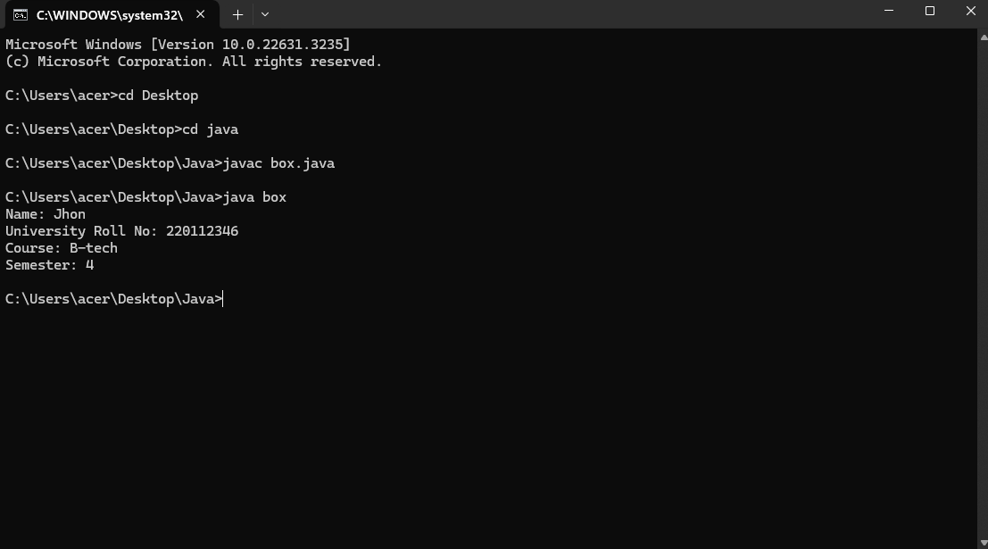

Q2. Using the switch statement, write a menu-driven program to calculate the maturity amount of a bank deposit.

The user is given the following options:

1. Term Deposit
2. Recurring Deposit

For option (i) accept Principal (p), rate of interest (r) and time period in years (n). Calculate and output the maturity amount (a) receivable using the formula a = p[1 + r / 100]n.

For option (ii) accept monthly installment (p), rate of interest (r) and time period in months (n). Calculate and output the maturity amount (a) receivable using the formula a = p * n + p * n(n + 1) / 2 * r / 100 * 1 / 12. For an incorrect option, an appropriate error message should be displayed.

[ Use Scanner Class to take input ]

**Source code:**

import java.util.Scanner;

public class box {

public static void main(String[] args) {

Scanner scanner = new Scanner(System.in);

System.out.println("Menu:");

System.out.println("1. Term Deposit");

System.out.println("2. Recurring Deposit");

System.out.print("Enter your choice (1 or 2): ");

int choice = scanner.nextInt();

switch (choice) {

case 1:

System.out.print("Enter Principal amount: ");

double principal1 = scanner.nextDouble();

System.out.print("Enter Rate of Interest: ");

double rate1 = scanner.nextDouble();

System.out.print("Enter Time period in years: ");

double years1 = scanner.nextDouble();

double maturityAmount1 = principal1 * Math.pow((1 + rate1 / 100), years1);

System.out.println("Maturity Amount for Term Deposit: " + maturityAmount1);

break;

case 2:

System.out.print("Enter Monthly Installment: ");

double installment = scanner.nextDouble();

System.out.print("Enter Rate of Interest: ");

double rate2 = scanner.nextDouble();

System.out.print("Enter Time period in months: ");

double months = scanner.nextDouble();

double maturityAmount2 = installment * months + installment * months * (months + 1) / 2 * rate2 / 100 * 1 / 12;

System.out.println("Maturity Amount for Recurring Deposit: " + maturityAmount2);

break;

default:

System.out.println("Invalid choice! Please choose either 1 or 2.");

}

scanner.close();

}

}

**Output:**

Q3. Program to find if the given numbers are Friendly pair or not (Amicable or not). **Friendly Pair** are two or more numbers with a common abundance.

**Input & Output format:**

* Input consists of **2 integers**.
* The first integer corresponds to number 1 and the second integer corresponds to number 2.

If it is a Friendly Pair display **Friendly Pair** or displays Not Friendly Pair.

For example,6 and 28 are Friendly Pair.

(Sum of divisors of 6)/6 = (Sum of divisors of 28)/28.

Steps to check whether the given numbers are friendly pair or not

* + Input the numbers num1 and num2.
  + Initialize sum1 = sum2 = 0.
  + sum1 = sum of all divisors of num1.
  + sum2 = sum of all divisors of num2.
  + If (sum1 == num1) and (sum2 == num2), then print "Abundant Numbers".
  + Else, print "Not Abundant Numbers".

Program to check whether the given numbers are friendly pair or not

**Source code:**

import java.util.Scanner;

public class box {

public static void main(String[] args) {

Scanner scanner = new Scanner(System.in);

System.out.print("Enter the first number: ");

int num1 = scanner.nextInt();

System.out.print("Enter the second number: ");

int num2 = scanner.nextInt();

int sum1 = sumOfDivisors(num1);

int sum2 = sumOfDivisors(num2);

if (sum1 == num1 && sum2 == num2) {

System.out.println("Friendly Pair");

} else {

System.out.println("Not Friendly Pair");

}

scanner.close();

}

public static int sumOfDivisors(int num) {

int sum = 0;

for (int i = 1; i <= num / 2; i++) {

if (num % i == 0) {

sum += i;

}

}

return sum;

}

}

**Output:**

Q1. Write a java program to take input as a command line argument. Your name, course, universityrollno and semester. Display the information.

Name:

University Roll No:

Course:

Semester:

**Source code:**

**Output:**

Q1. Write a java program to take input as a command line argument. Your name, course, universityrollno and semester. Display the information.

Name:

University Roll No:

Course:

Semester:

**Source code:**

**Output:**

Q1. Write a java program to take input as a command line argument. Your name, course, universityrollno and semester. Display the information.

Name:

University Roll No:

Course:

Semester:

**Source code:**

**Output:**

Q1. Write a java program to take input as a command line argument. Your name, course, universityrollno and semester. Display the information.

Name:

University Roll No:

Course:

Semester:

**Source code:**

**Output:**

Q1. Write a java program to take input as a command line argument. Your name, course, universityrollno and semester. Display the information.

Name:

University Roll No:

Course:

Semester:

**Source code:**

**Output:**

Q1. Write a java program to take input as a command line argument. Your name, course, universityrollno and semester. Display the information.

Name:

University Roll No:

Course:

Semester:

**Source code:**

**Output:**

Q1. Write a java program to take input as a command line argument. Your name, course, universityrollno and semester. Display the information.

Name:

University Roll No:

Course:

Semester:

**Source code:**

**Output:**